SIMPLE EMBEDDED SYSTEMS

LINE FOLLOWER ROBOT

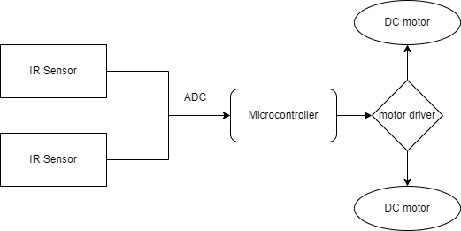

The above block diagram is of Line Follower Robot.

**IR SENSOR**:

* Electronic Device.
* Emits light to Sense objects.
* Senses Radiation which are invisible to eyes.
* Emitter is IR Led.
* Detector is IR Photo diode.

**8051 Microcontroller:**

* 8 bit microcontroller .
* 4kb rom
* 128 bytes ram.
* 2-16 bit timers**.**

**Motor Driver:**

* Capable of running two motors .
* Direction of two motors can be controlled independently.

**DC Motor:**

* These are small motors .
* Needs low current.
* Acts as a actuator.

**Requirements:**

* + High Level Requirements.
  + Low Level Requirements.

High Level Requirements:

|  |  |
| --- | --- |
| **High Level Requirements** | **Description** |
| HLR1 | IR sensor |
| HLR2 | Microcontroller |
| HLR3 | Motor Driver |
| HLR4 | DC Motor |

Low Level Requirements:

|  |  |
| --- | --- |
| **Low Level Requirements** | **Description** |
| LLR1 | Senses path |
| LLR2 | Atmega 328 |
| LLR3 | Controls motor |
| LLR4 | Actuator |